**GOURAV SINGJAL**

Registration Number: 11701750

Lovely Professional University, Punjab

E-mail: [singhal.gourav98@gmail.com](mailto:singhal.gourav98@gmail.com)

Github Account: <https://github.com/gouravsinghal>

Linkedin Profile: [https://www.linkedin.com/in/singhalgourav98 /](https://www.linkedin.com/in/singhalgourav98%20/)

Contact No.: +91-7015721450

**Final Submission for GoodHealth Frontend Assignment**

As I tried to complete assignment with all the requirements required by the company . Here I am giving Details and tradeoffs that I faced while making this Project. I Used Twilio API to send OTP.

Here is my github repository link:-

<https://github.com/gouravsinghal/goodhealthotpassignment/>

**Setup Process:**

1. Firstly, install any text editor (Sublime Text).
2. Then, I install Xampp becauseit is the most popular PHP development environment for Windows. It allows us to build web pages offline, on a local web server on your computer. 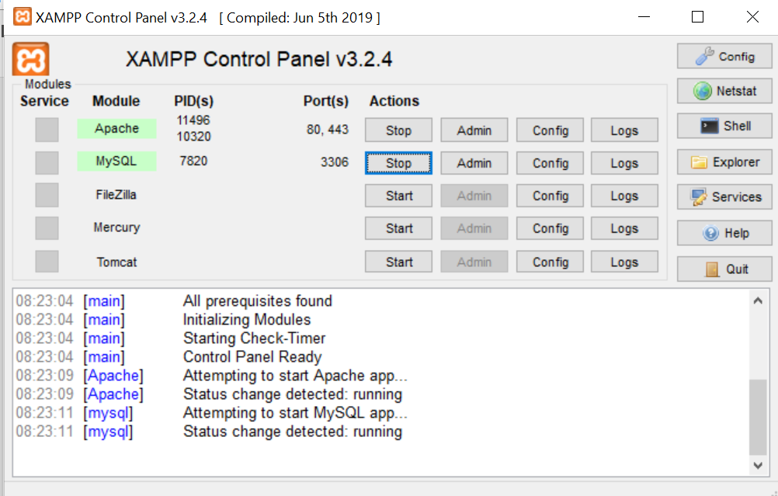
3. After installing Xampp, I install composer to allow us to manage our libraries, classes, and functions throughout our applications. I installed composer to use Twilio Api. 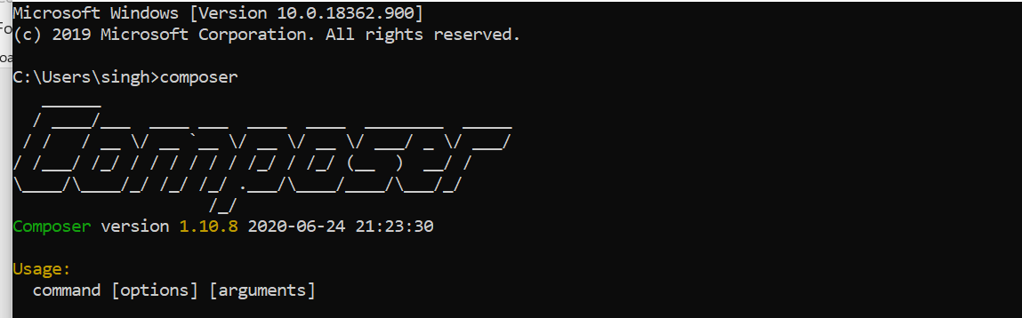
4. As mention for Authentication we used twilio Api as it allows you to query metadata about your account, phone number, calls, text messages, and recordings. we can also do some fancy things like initiate outbound calls and sent text messages. 
5. Create Account on Twilio API and note Account SID and AUTH TOKEN and create a number there. 

**Building Process:**

1. I create Web pages which include Home page(index.php), login page(login.php), signup page(signup.php) and welcome screen (welcome.php) and onr OTP page (number.php) as per task requirement. The frontend of these pages were built using Html, Css, Javascript and bootstrap and the work for data controlling I used PHP here to store data in Json file named as data.jason. 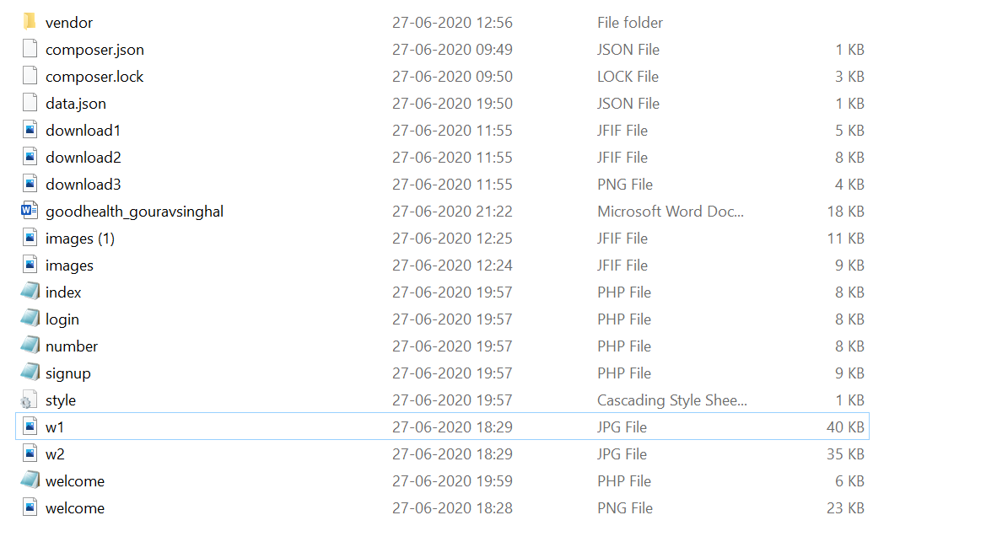
2. So to make web pages more responsive I use PHP here. As it is a server scripting language and a powerful tool for making dynamic and interactive Web pages.
3. I used bootstrap grid view to make my Page responsive for the different size of the slide or viewer.
4. Using Html helps provides the basic structure of sites, which is enhanced and modified by other technologies like CSS and JavaScript.CSS is used to control presentation, formatting, and layout where JavaScript is used to control the behavior of different elements.

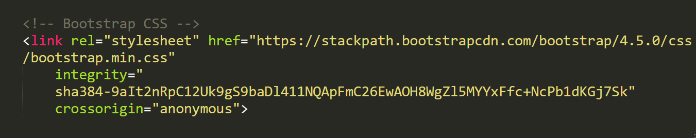

1. Bootstrap as we know it is the most popular HTML, CSS, and JavaScript framework for developing responsive, mobile-first websites. Hence it enhance my website creativity.

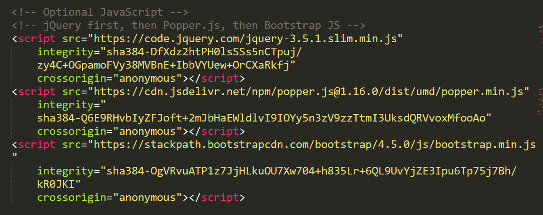

1. And for local data storage we create a json file which includes all the details for signup and login process. The data was stored in simple manner.



**Working Process:**

1. Firstly, the phone no. by which a user want to login or signup must be verify by the twilio account of owner because we are using twilio trial account only.

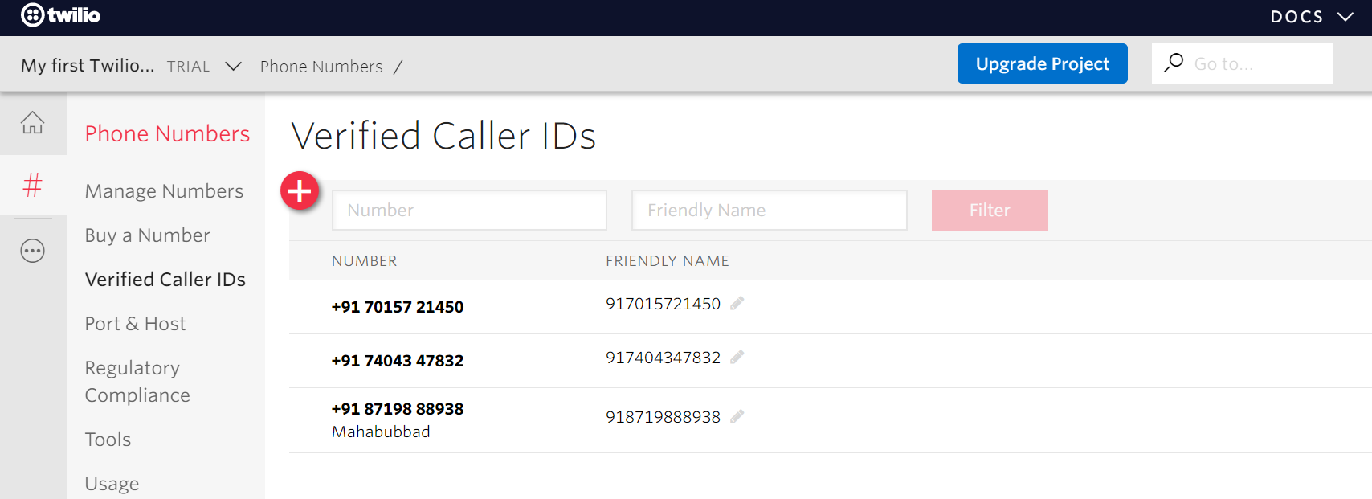

1. Then signup account and filled the details asked there which are email, name, password, contact number. Kindly remember the user email id, contact number and password because it will helps you to login.

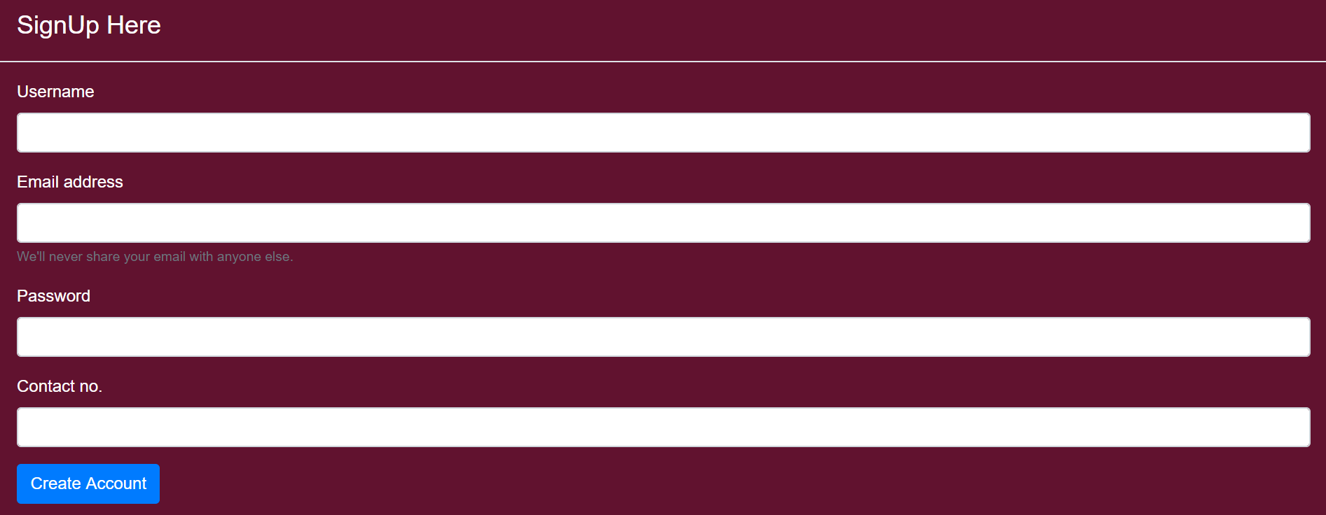

1. All the data of user while sign up will be automatically saved in Json file and and while login if your data is already in the json file then only you will allowed to login else you can’t login.

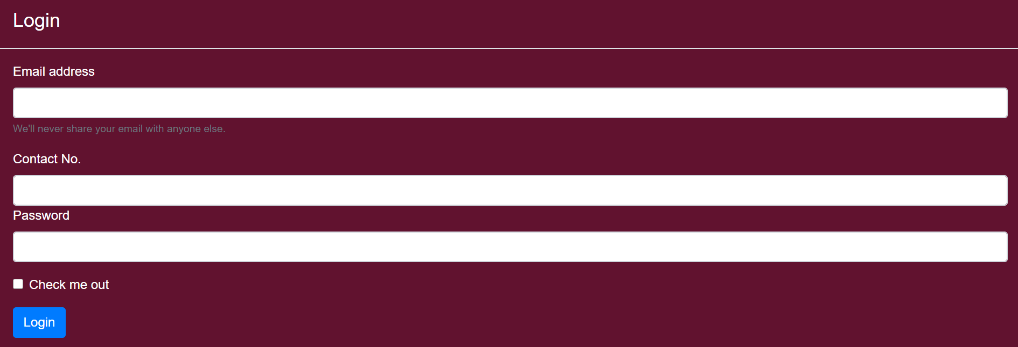

1. If we input wrong information there and if we enter the information of that user that is not exist in our json file then it will redirect it to our login.php page.
2. After, login you will be redirect to OTP verification page and OTP will automatically send to your registered mobile no. this whole process helps you to login with safety with the use of Twilio API.

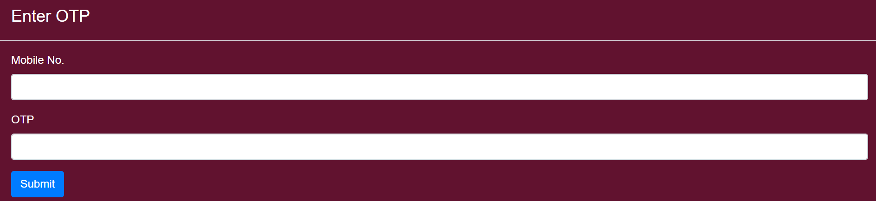

1. After successfully submitting the OTP you will be redirecting to the welcome where the users name will be printed on the screen.





**Design Modal:-**

1. Index.php

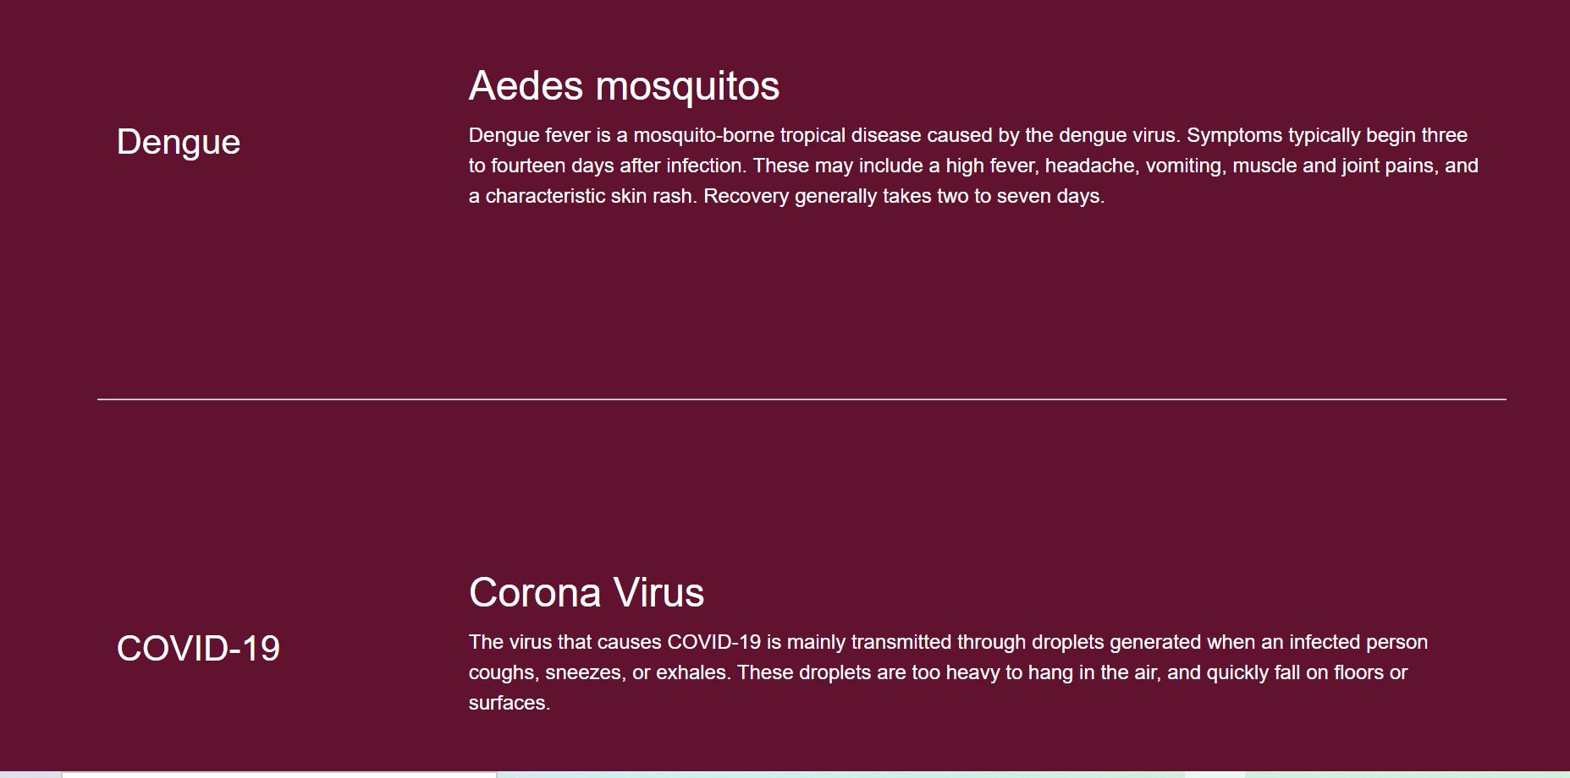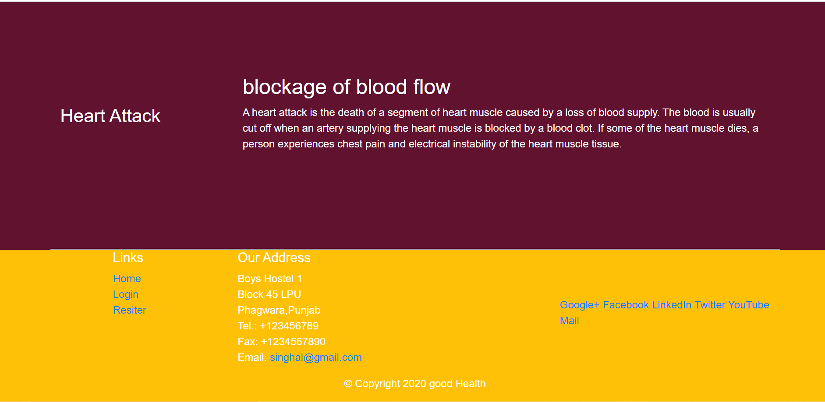

1. Singup.php

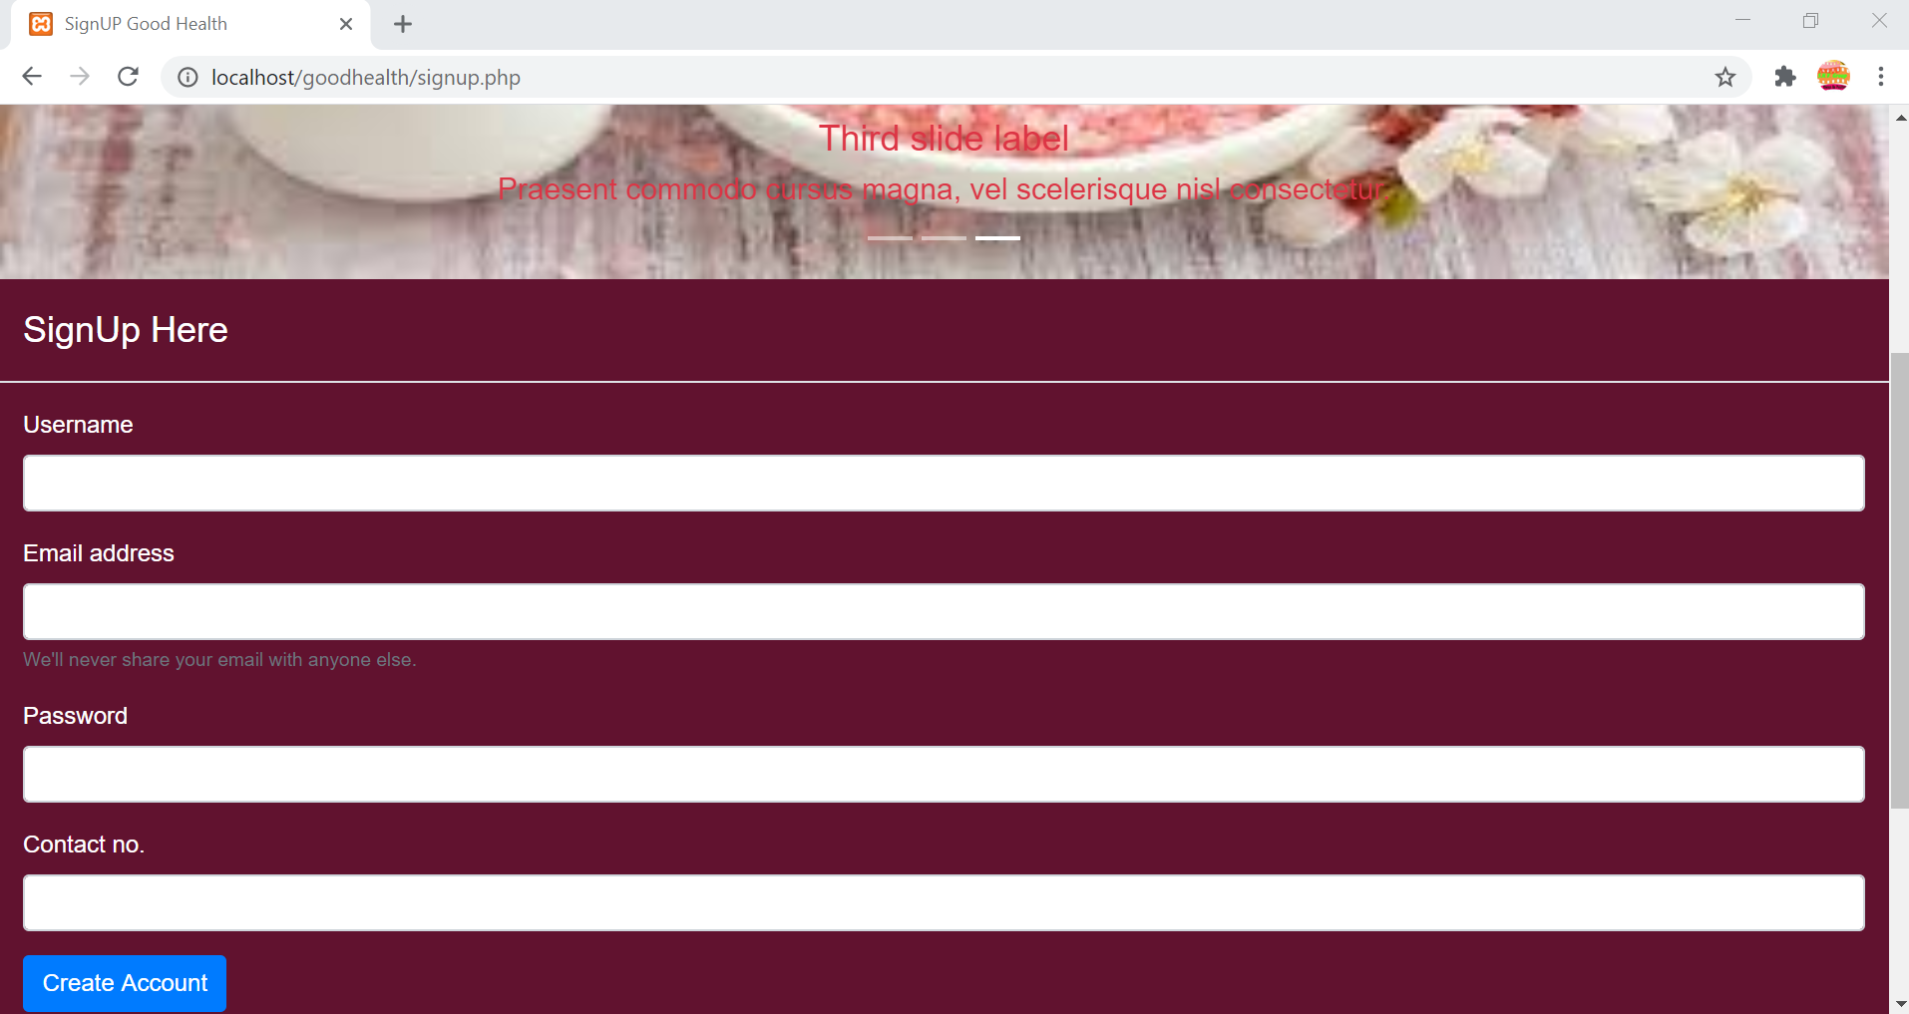

1. Login.php

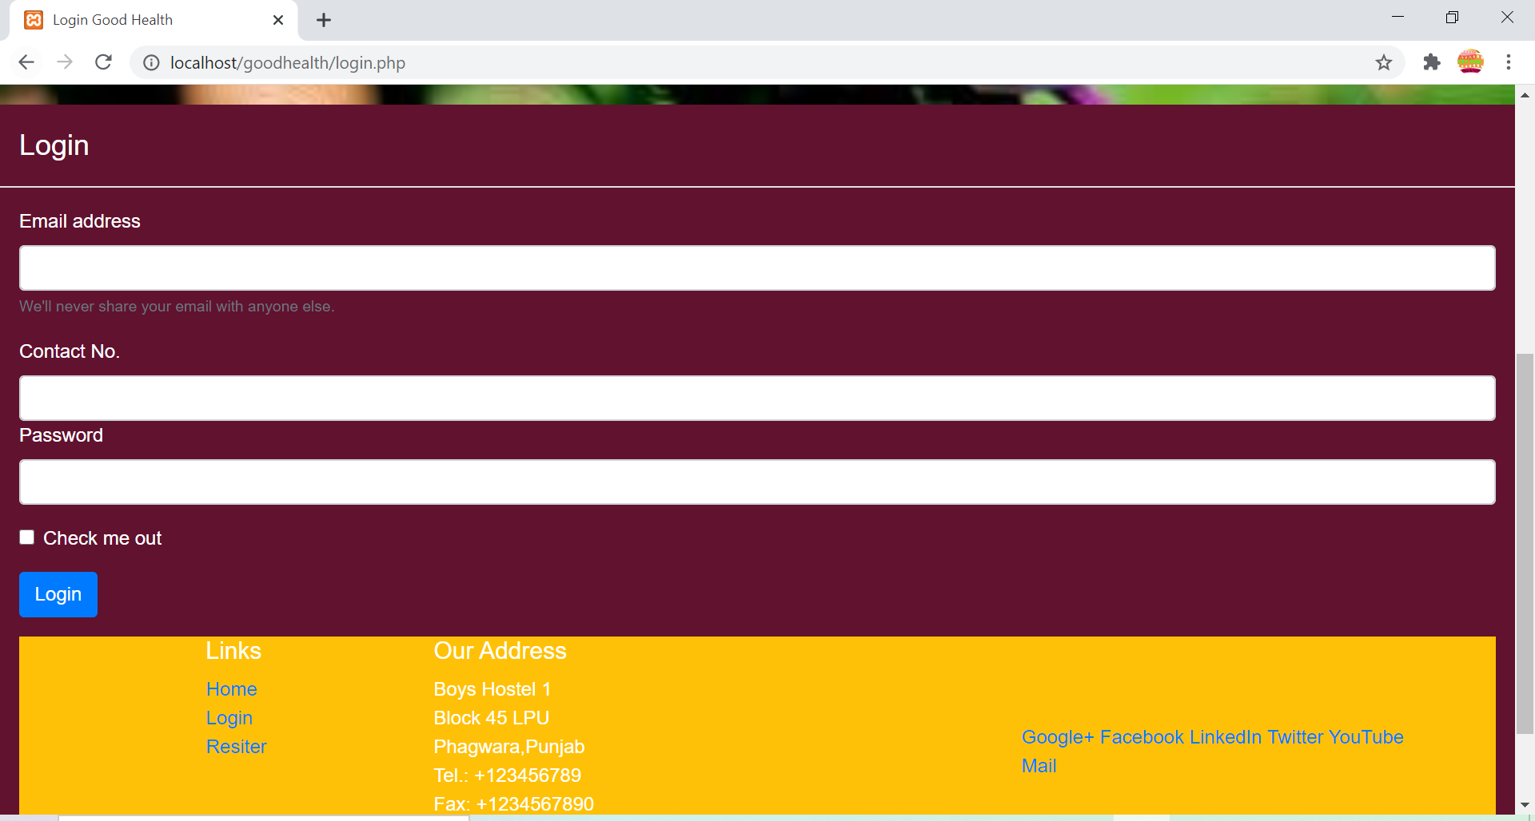

1. Number.php

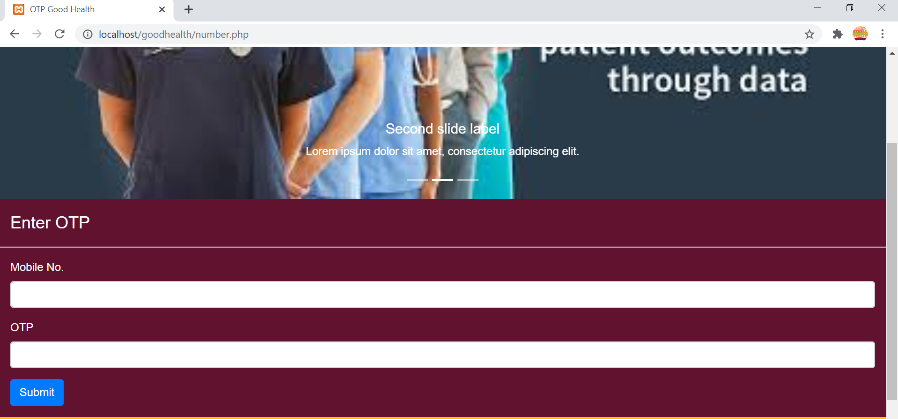

1. Welcome.php

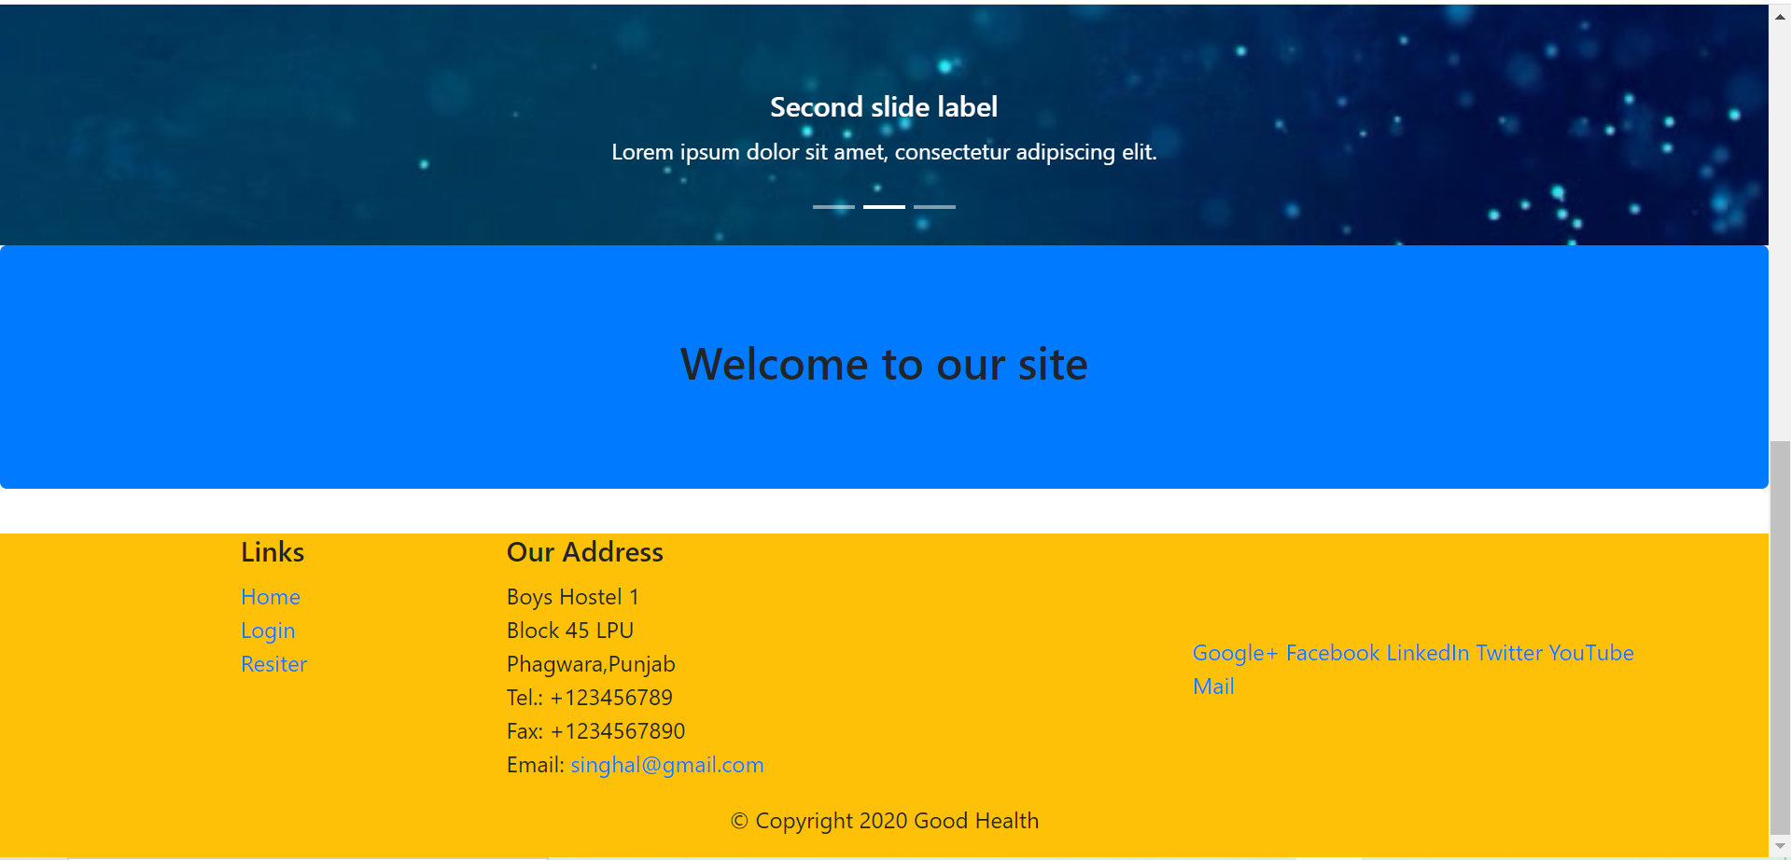

**Difficulties I Faced While Making This assignment:**

1. Firstly, its short time notice to use Twilio Api. Because it is new for me while I try to study this Api. I get to know that it is very useful in sending messages.
2. Its tough for me to store data in json file by javascript So to make easy I used Php to store and retrieve data from json file.
3. I used random function to generate OTP So its stored once in json file then it is same always .

**Technologies I used :-**

1. HTML
2. CSS
3. JavaScript
4. Bootstrap
5. PHP
6. Json
7. Xampp
8. Composer
9. Twilio Api

**References :-**

<https://www.w3schools.com/html/default.asp>

<https://www.twilio.com/docs/libraries/php>

<https://github.com/twilio/twilio-php>

<https://getbootstrap.com/>

And some from Youtube.